

**Chic Lighting & Design Website**

**Documentation**

|  |  |
| --- | --- |
| **Authors** | **C2111L - Team 1** |
| **Nam Nguyen Hoang**  **Son Nguyen Duc Hoang**  **Thanh Nguyen Tai** |
| **Date** | **13-Sep-2022** |
| **Instructor** | **Toan Ngo Vinh** |

Hanoi, September 13, 2022.

**Index**

**1. Problem Definition** 1

**1.1. Problem Abstraction** 1

**1.2. The Current System** 1

**1.3. The Proposed System** 1

***1.3.1. Boundaries of the System*** 1

***1.3.2. Hardware and Software Requirement*** 1

**2. Customer Requirements Specification** 2

**2.1. Users of the System** 2

**2.2. System functions** 2

**3. System Designs** 3

**3.1 Entity Relationship Diagram** 3

**3.2 Database Design** 3

**3.3 Sitemap** 7

**3.4 System functions design** 7

**4. Task sheet** 26

**5. Validation Checklists** 27

**ACKNOWLEDGEMENT**

First and foremost, I, represented for Team 1 of C2111L, would like to thank our Teacher – Ngo Vinh Toan, who guided us in doing these projects. He provided us with invaluable advice and helped us in difficult periods. His motivation and help contributed tremendously to the successful completion of the project.

Besides, we would like to thank all the teachers who helped us by giving us advice and providing the equipment which we needed.

Also I would like to thank my family and friends for their support. Without that support we couldn’t have succeeded in completing this project.

At last but not in least, we would like to thank everyone who helped and motivated us to work on this project.

**1. Problem Definition**

**1.1. Problem Abstraction**

In 1971, Chic Lighting & Design was operated. For today's eclectic environments, we provide one-of-a-kind lighting and accessories in the most beautiful traditional and sophisticated contemporary styles. An online store called Chic Lighting & Design specializes in LED lights, lamps, chandeliers, and pendant lighting. Crystal chandeliers, conventional chandeliers, contemporary chandeliers, glass pendant lights, industrial and vintage pendant lights, metal pendant lights, and many more are among the selections we provide.

**1.2. The Current System**

These days, our needs are expanding. The need for home decoration is also one of them. So gorgeous lights are great items to make our home more beautiful. However, traveling a lot or going far is what makes it difficult for us to find and buy light bulbs. Therefore, we "group 1" will build a chic and lighting website where people can shop online without having to move. We hope that this website will contribute to everyone with quality and beautiful light bulbs

**1.3. The Proposed System**

in this our project we build website with some functions as follows:

* Allows users to register for an account
* Allow users to log into accounts
* Add product to cart
* Send Feedback
* Edit account (retrieve password, change password)

***1.3.1. Boundaries of the System***

Due to the limitation of time, experience and knowledge, our website still has some disadvantages:

* Can only apply COD
* No language change feature
* Search products

***1.3.2. Hardware and Software Requirement***

**Hardware**

* Intel Core i3/i5 Processor or higher
* 8 GB RAM or above
* Color SVGA
* 500 GB Hard Disk space
* Mouse
* Keyboard

**Software**

Technologies to be used:

* Frontend: HTML5, CSS, Bootstrap, JavaScript,
* Backend: PHP
* Data Store: JSON files or TXT files

**2. Customer Requirements Specification**

**2.1. Users of the System**

2.1.1. Unregistered users:

* Visit homepage
* Visit the product page
* Visit product detail page
* Visit the about page

2.1.2. Registered users:

They can access all functions just like unregistered users. In

addition, they can use some additional functions:

* Add to cart, order
* Send feedback
* Change,recover password
* View profile

2.1.3. Admin:

* Product management
* Add product
* Add brand
* Order management
* User management

**2.2. System functions**

2.2.1. Register

* Input: The users enter their information from the keyboard
* Process: The user's information will be inserted into the table in the database
* Output: The user's screen will switch to the home page

2.2.2. Login

* Input: The users enter their account name and password from the keyboard
* Process: If the correct username and password exist in the database, switch to the home page. Otherwise, error message will appear on screen
* Output: The user's screen will switch to the home page

2.2.3. Log out

* Input: The users click on the log out button
* Process: session will be terminated
* Output: The user's screen will switch to the home page

2.2.4. Feedback

* Input: The users enter their feedback
* Process: insert user’s feedback into database
* Output: The page will reload

2.2.5. Change Password

* Input: The users enter the old and new password
* Process: Update the table in database
* Output: Print the message of successful password change on the screen

2.2.6. Add to cart

* Input: The users click on the Add to Cart button
* Process: Insert into the table in database
* Output: Show the cart

**3. System Designs**

**3.1 Entity Relationship Diagram**

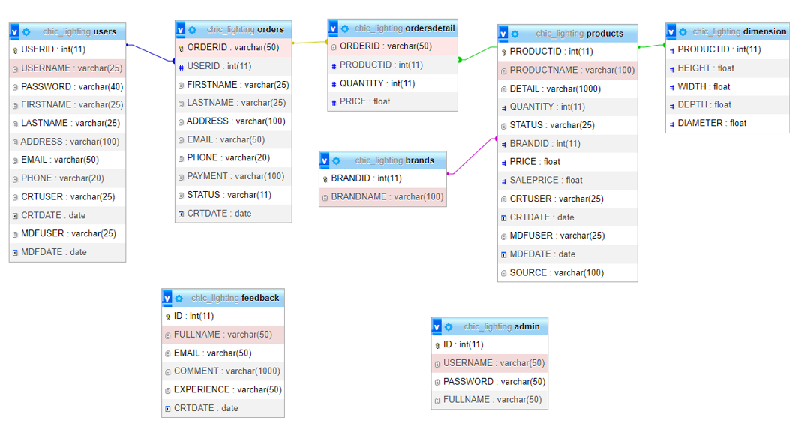

**3.2 Database Design**

Admin

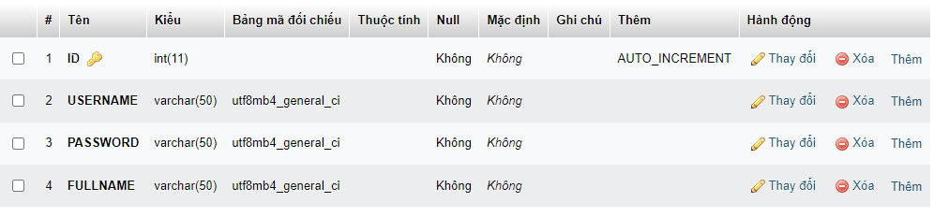

Brand

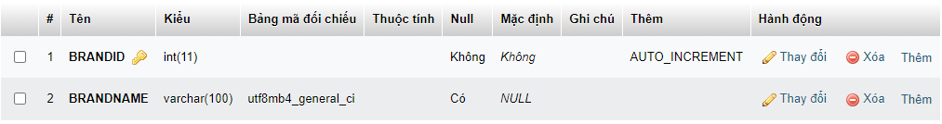

Dimension

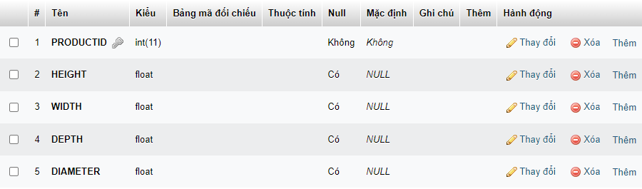

Feedback

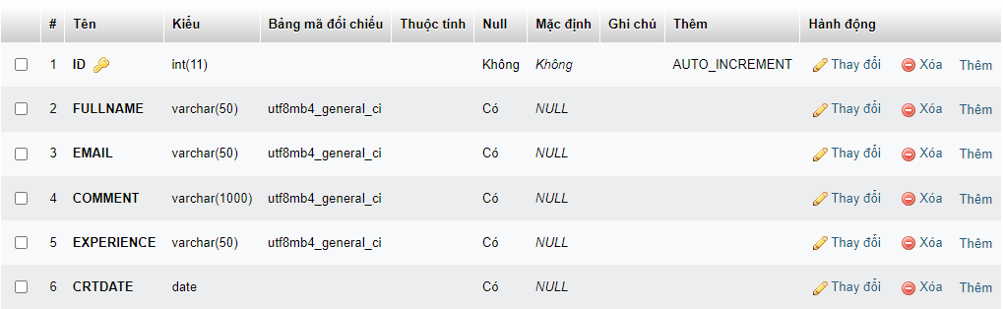

Orders

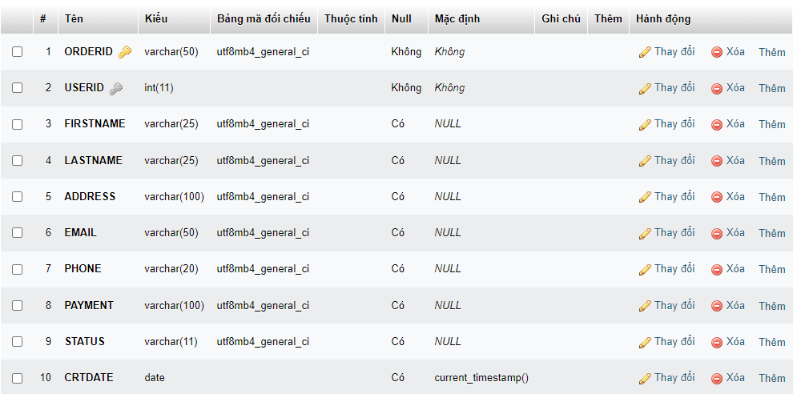

Orderdetails

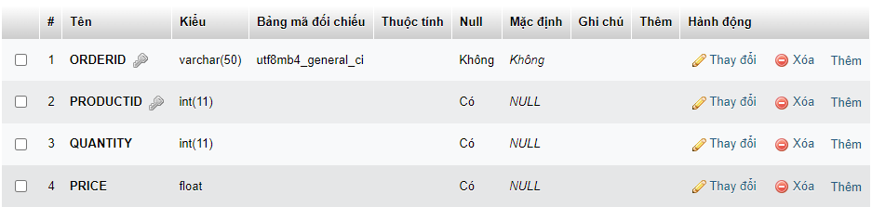

Products

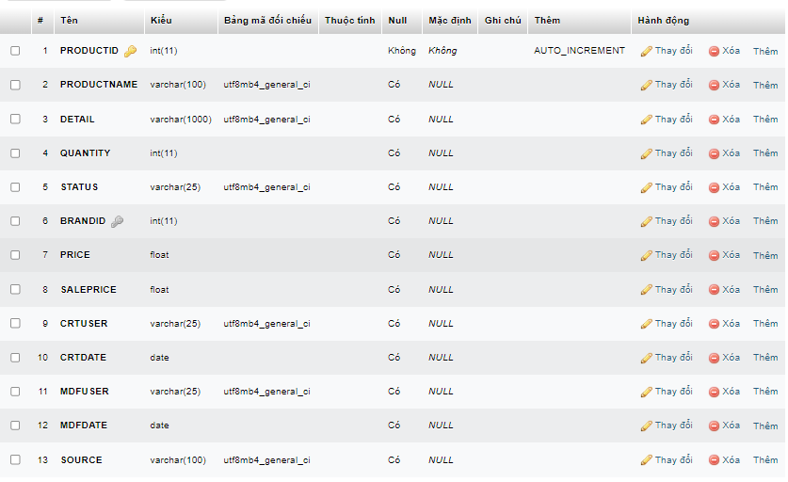

Users

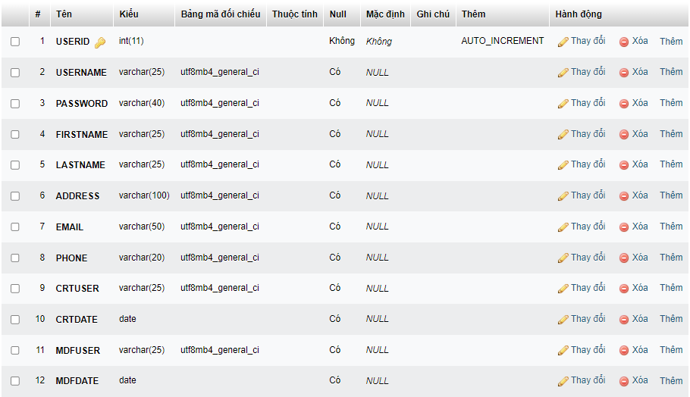

**3.3 Sitemap**

**User site**

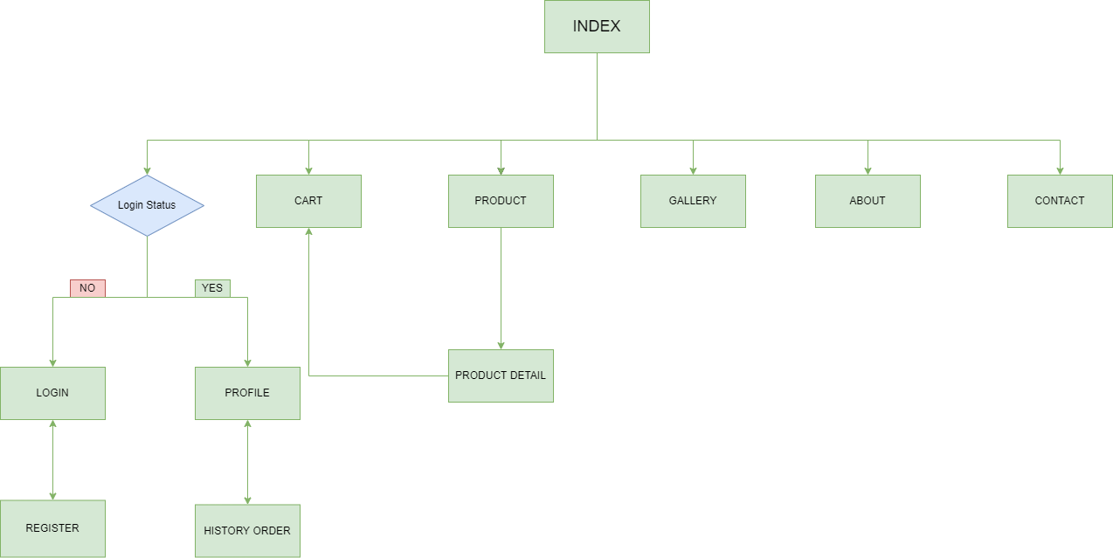

**Admin site**

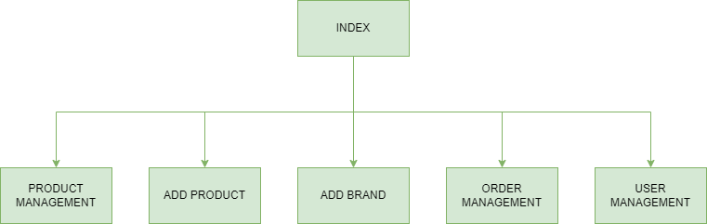

**3.4 System functions design**

User page:

Register

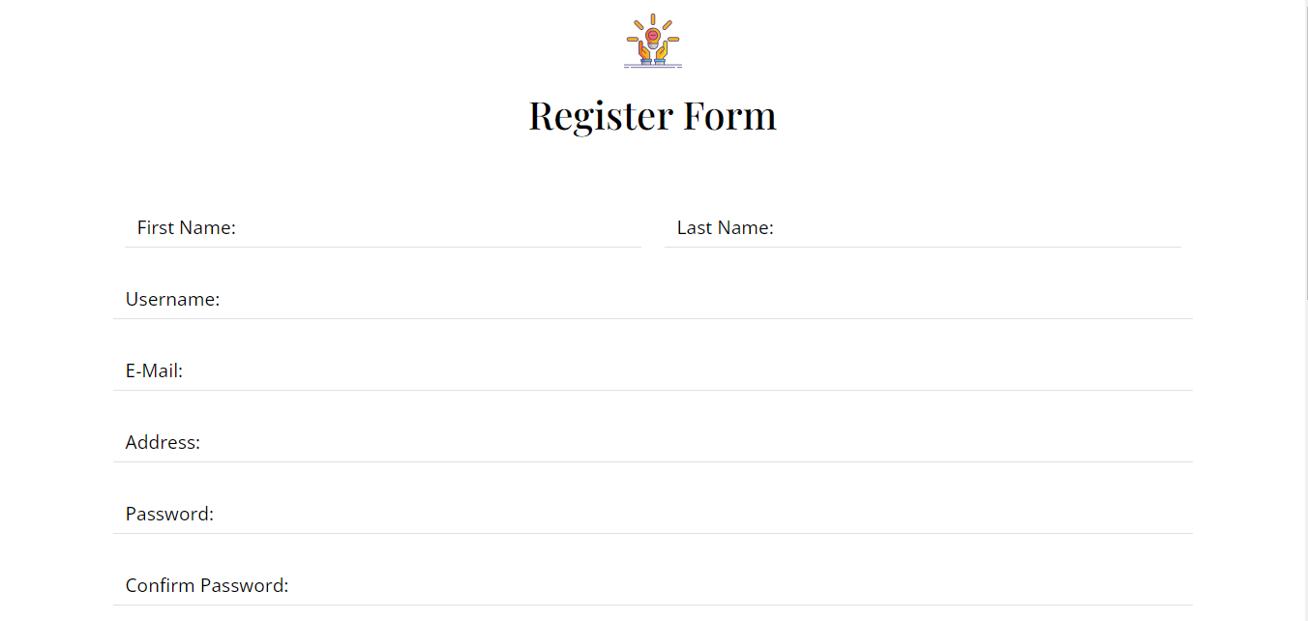

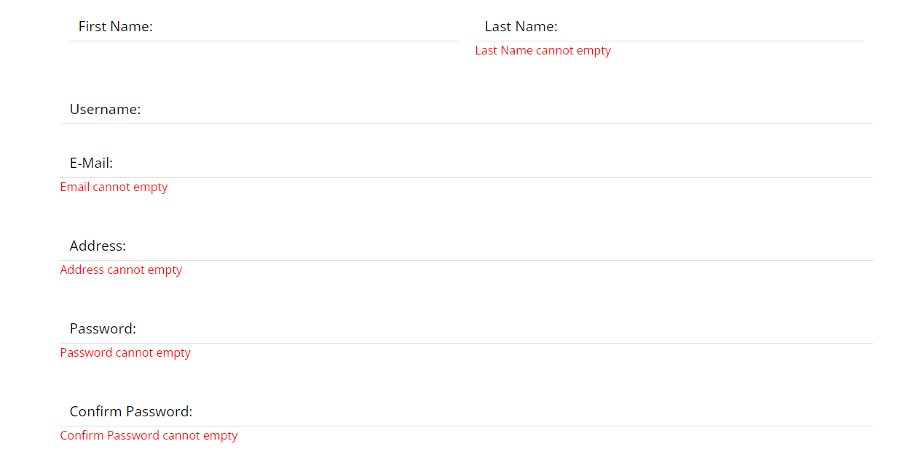

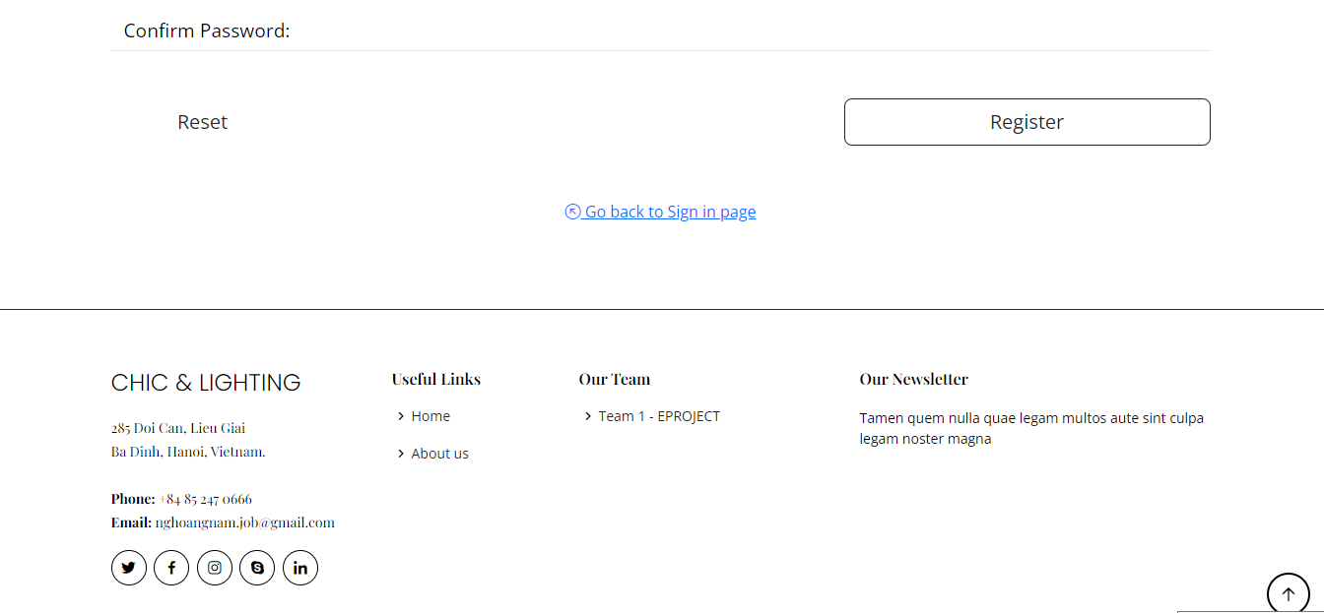

\

Login

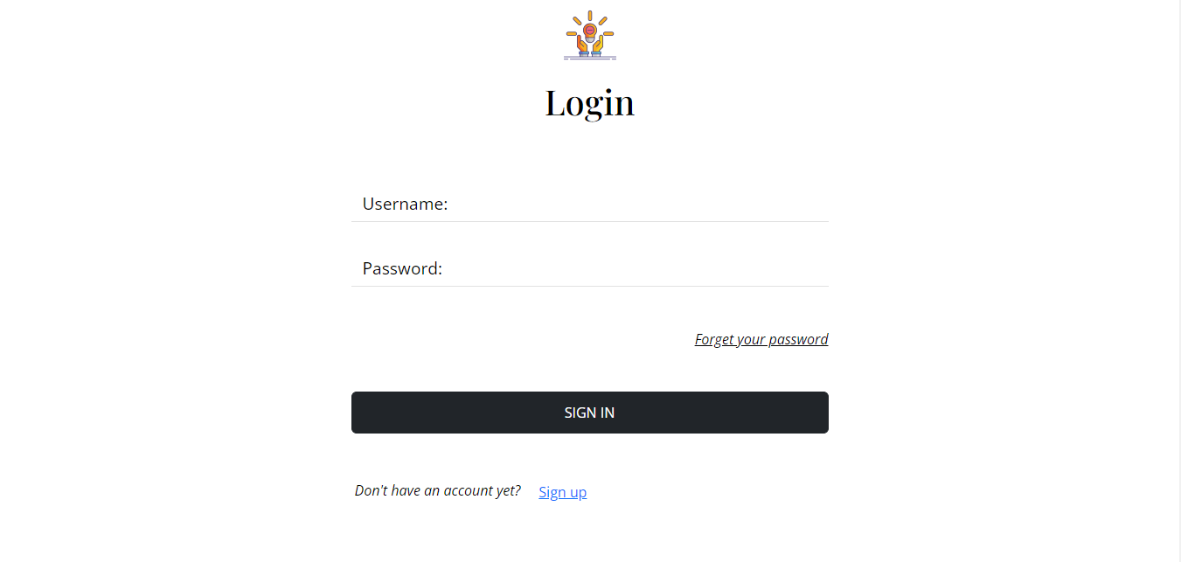

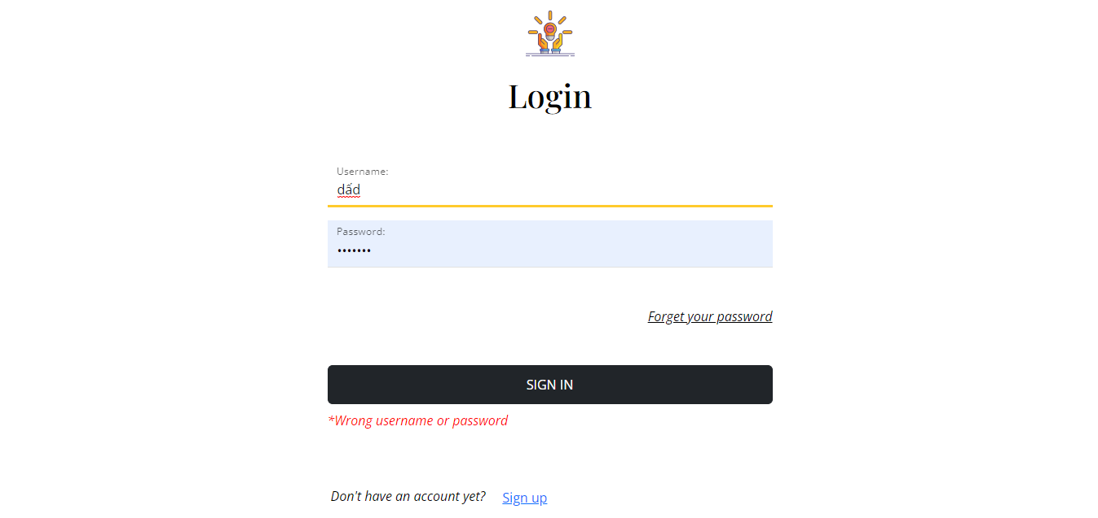

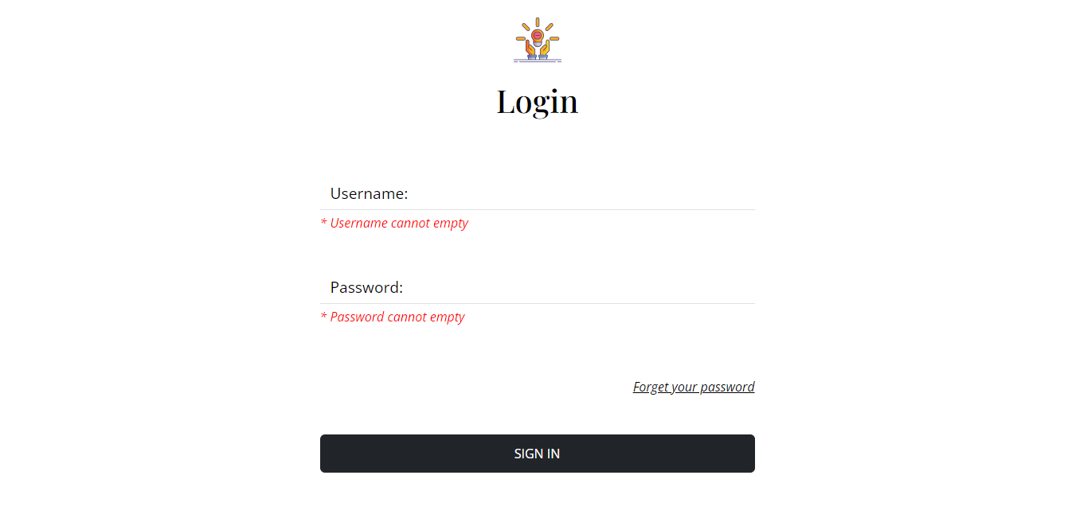

Index

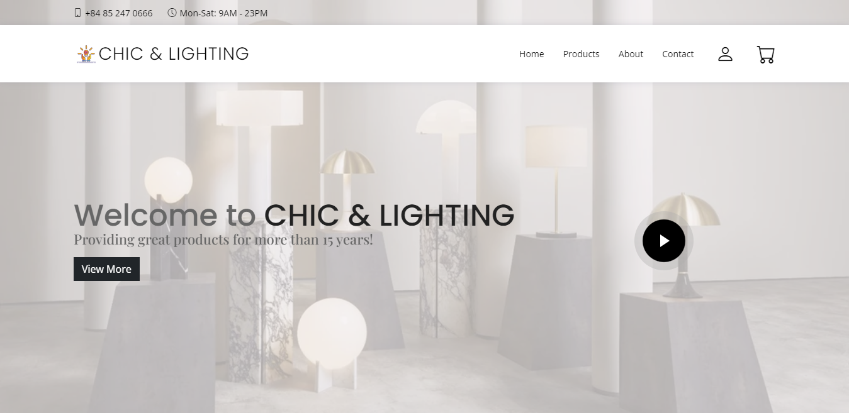

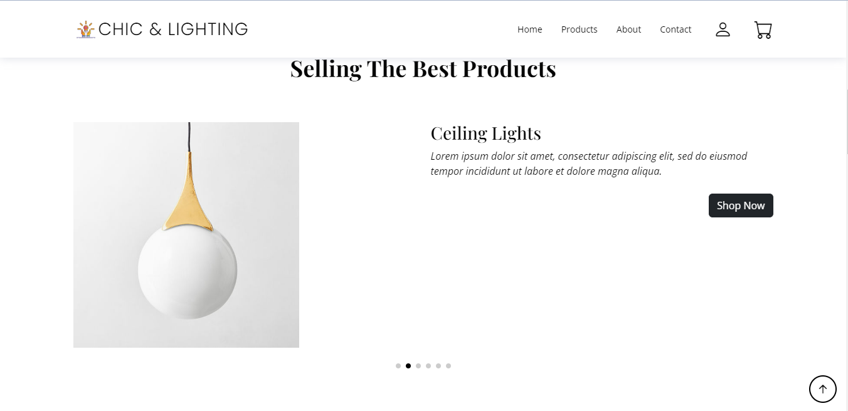

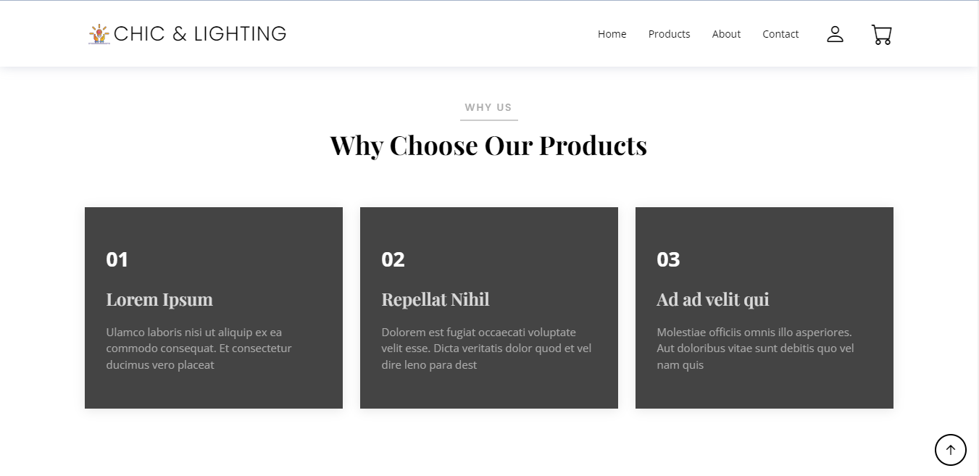

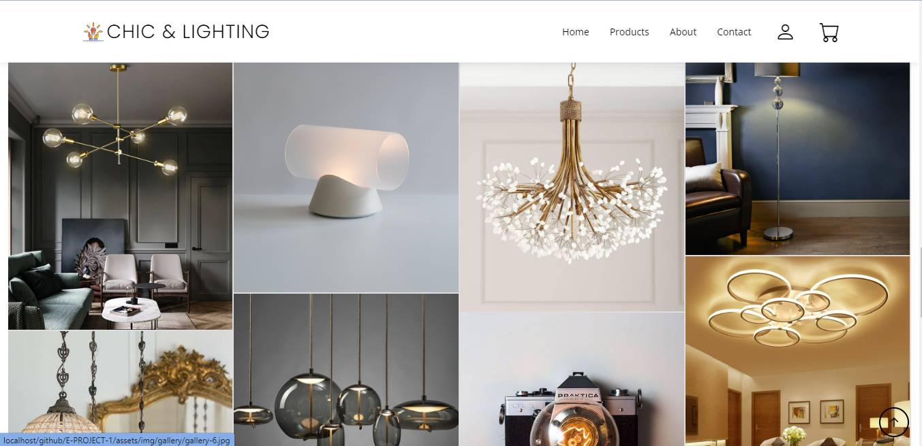

Feedback

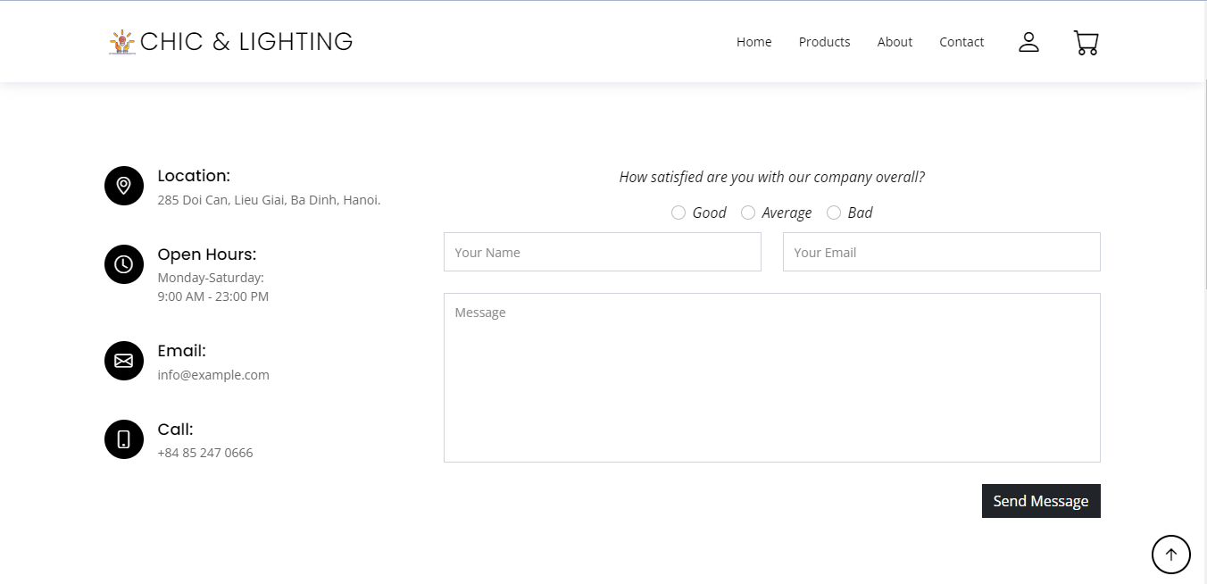

About

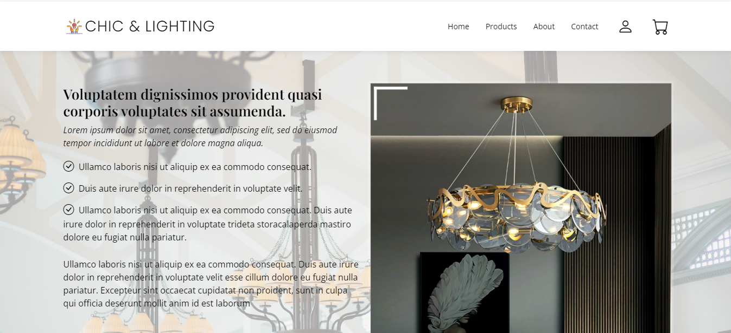

Products

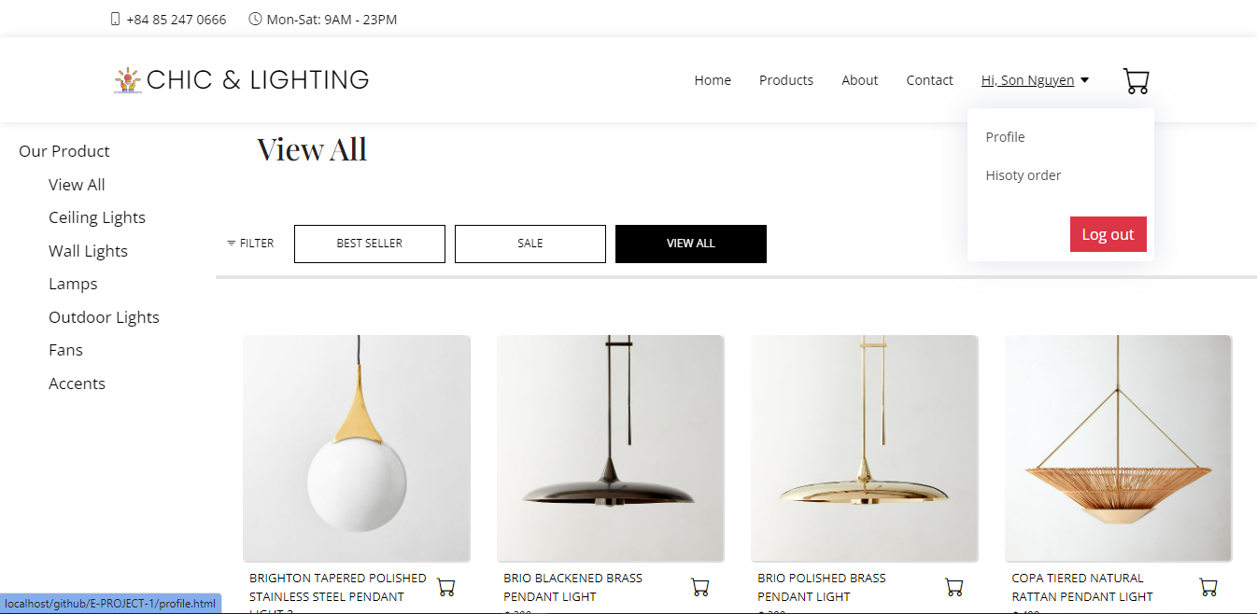

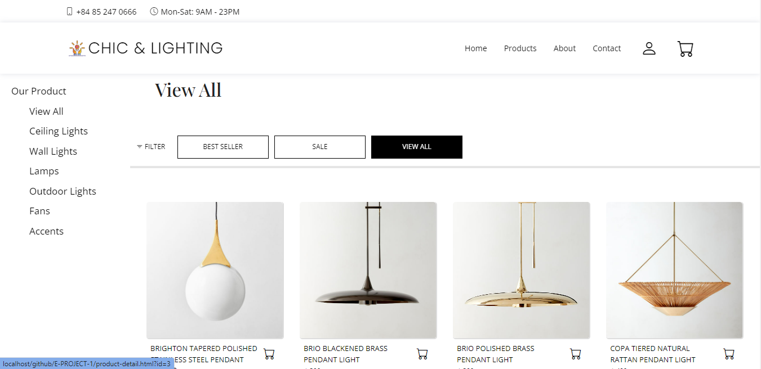

Profile

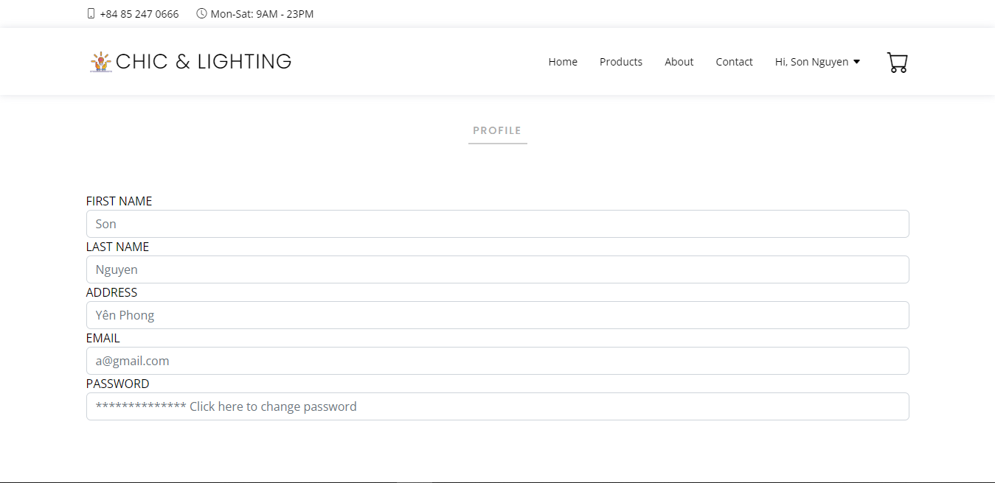

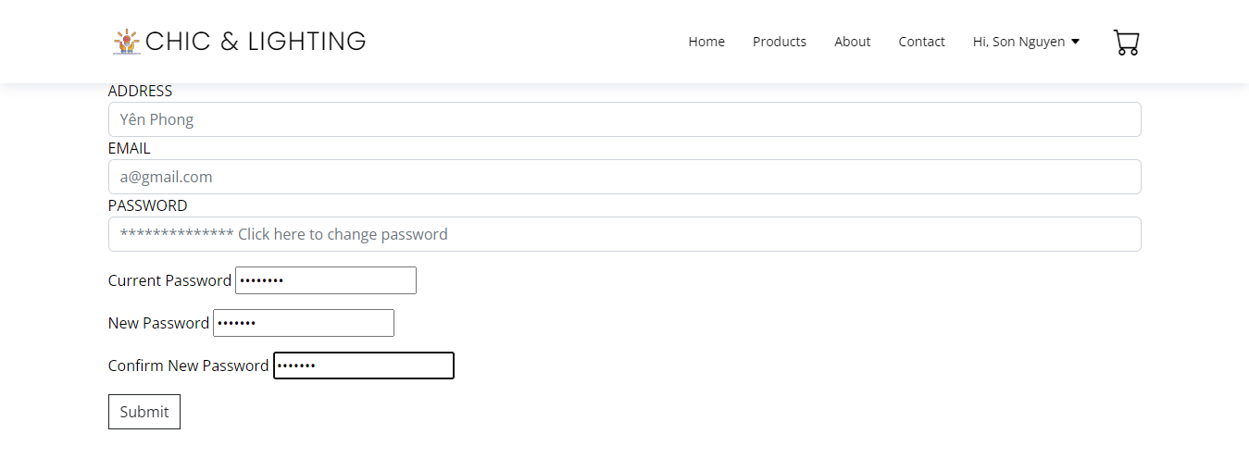

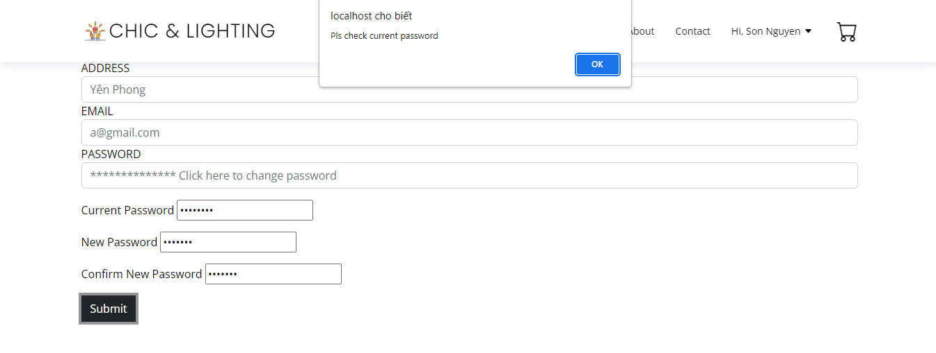

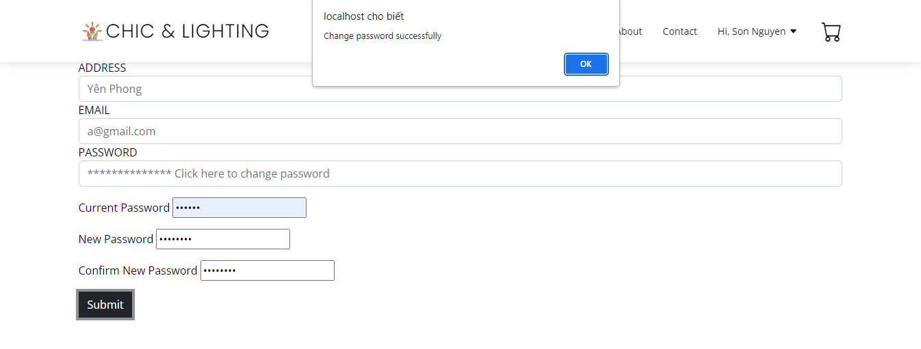

History Order

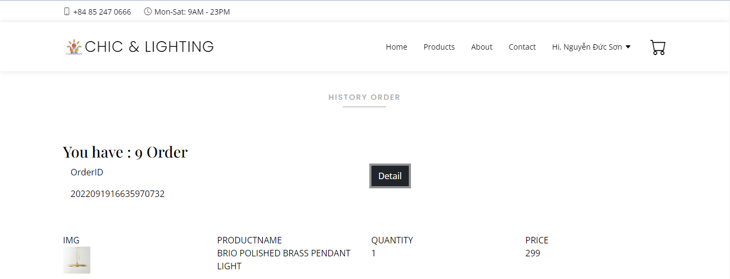

Product Details

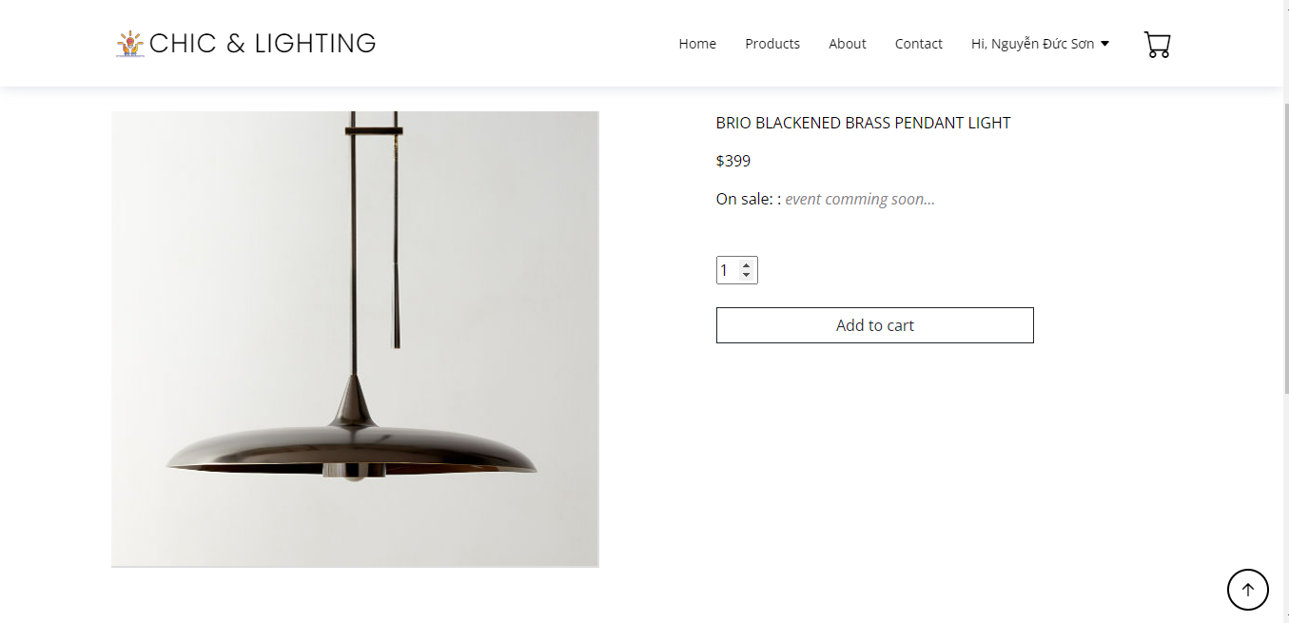

Cart

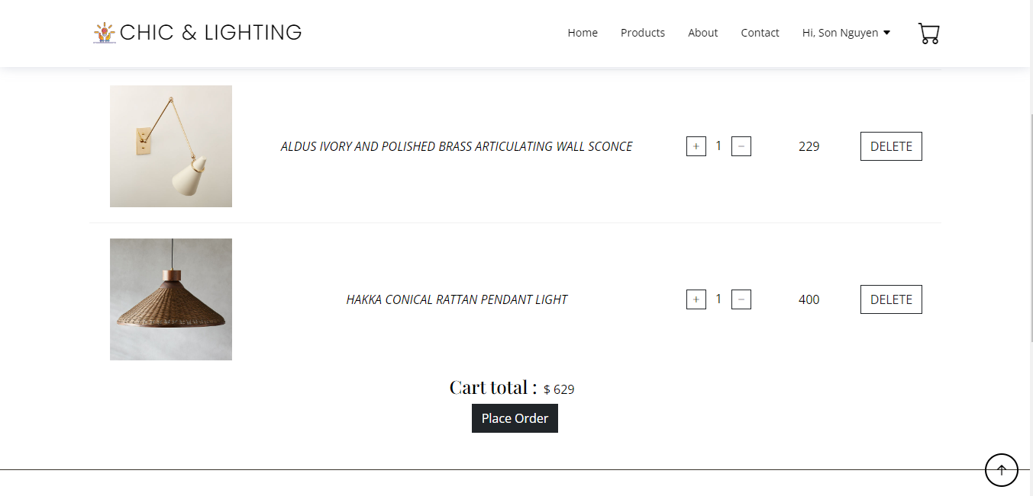

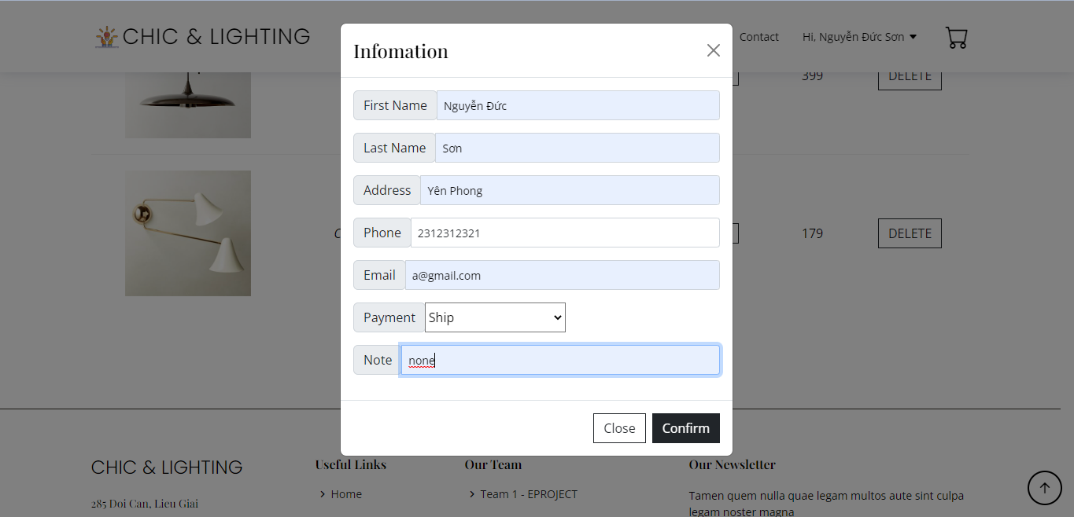

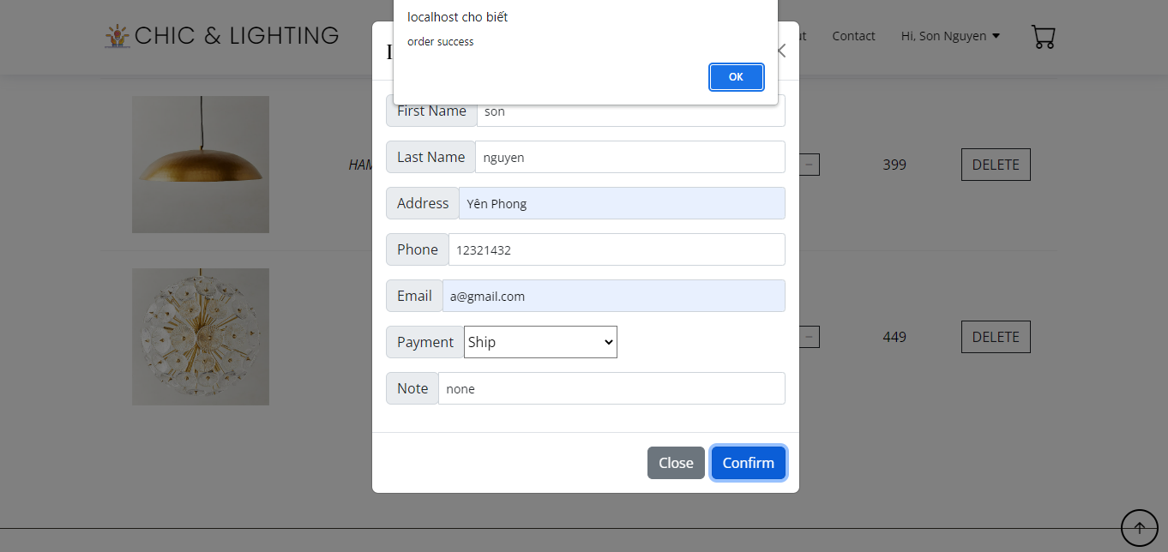

Admin page:

Login

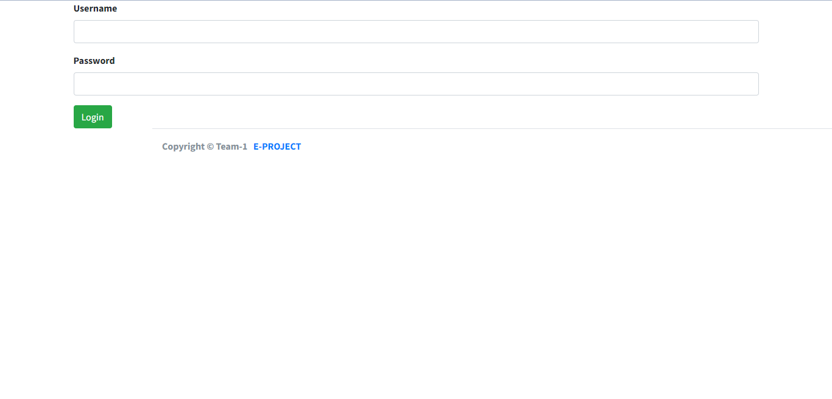

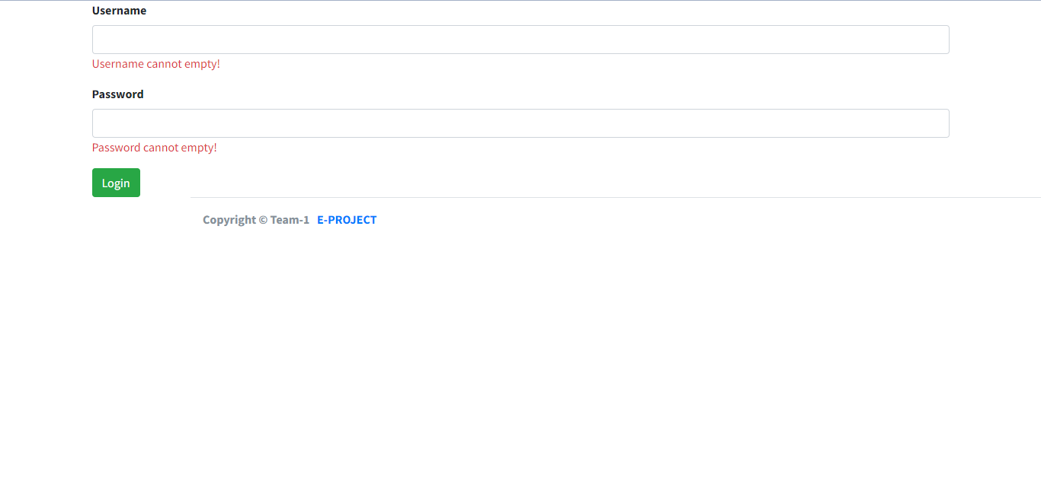

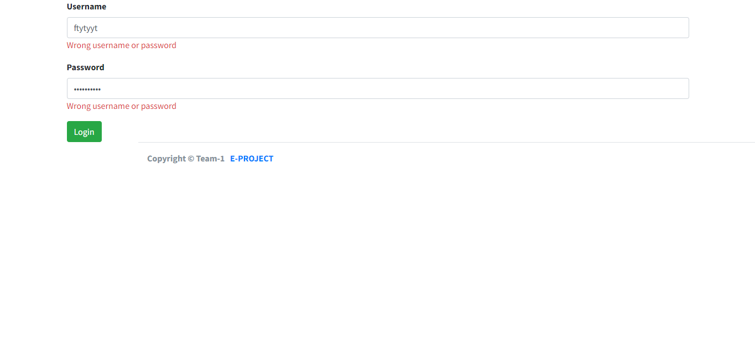

Index

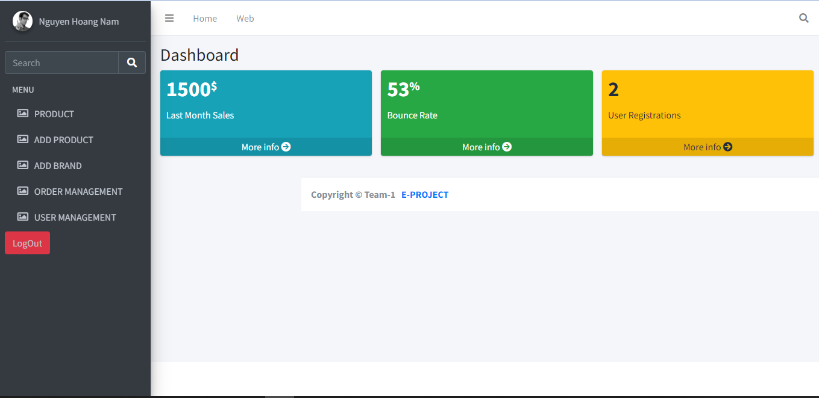

Product management

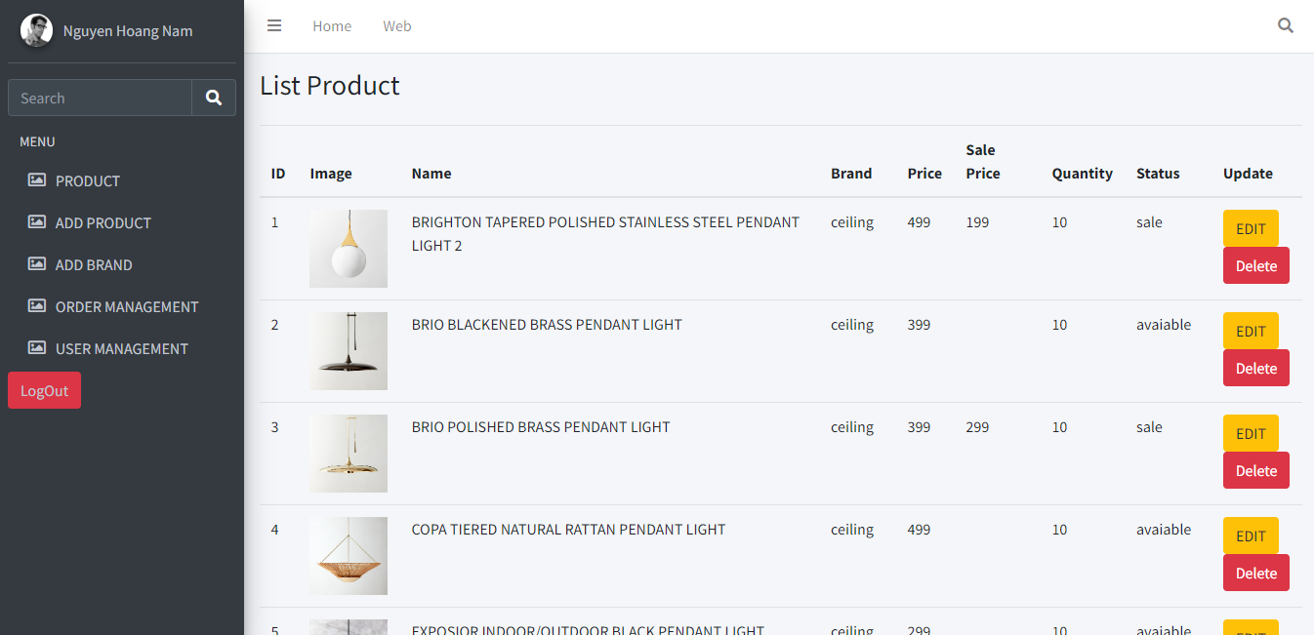

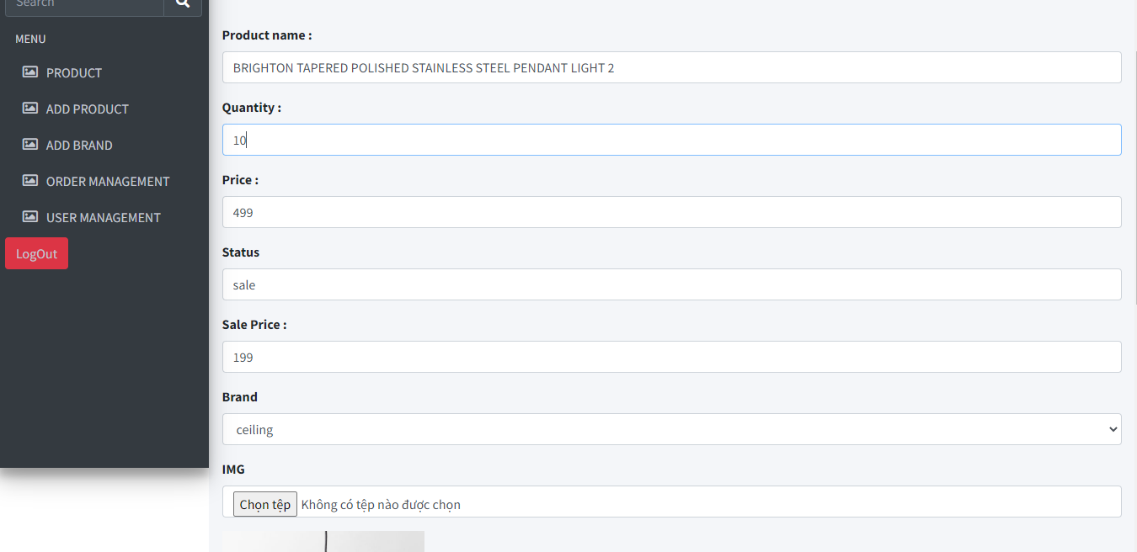

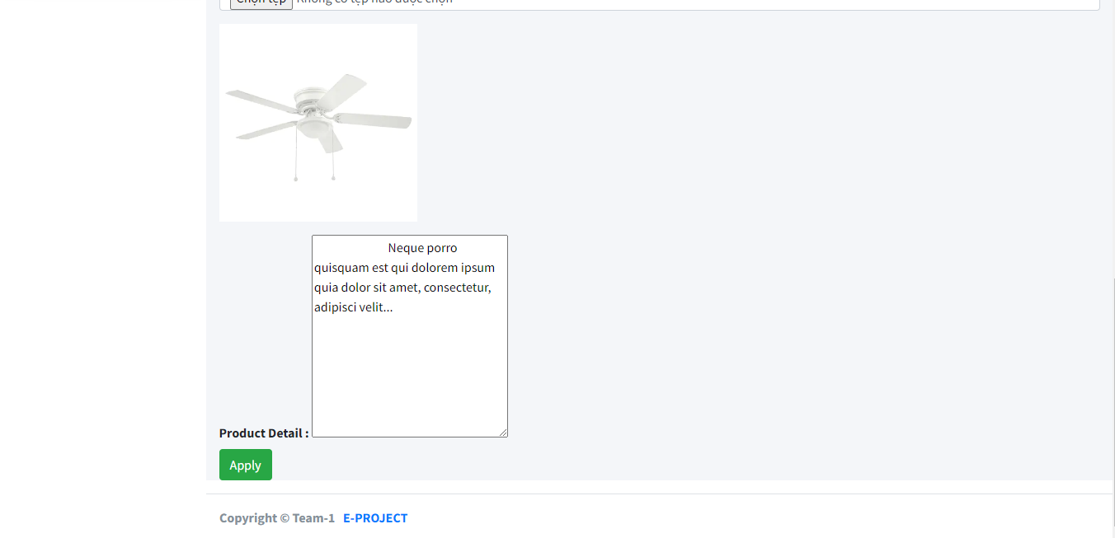

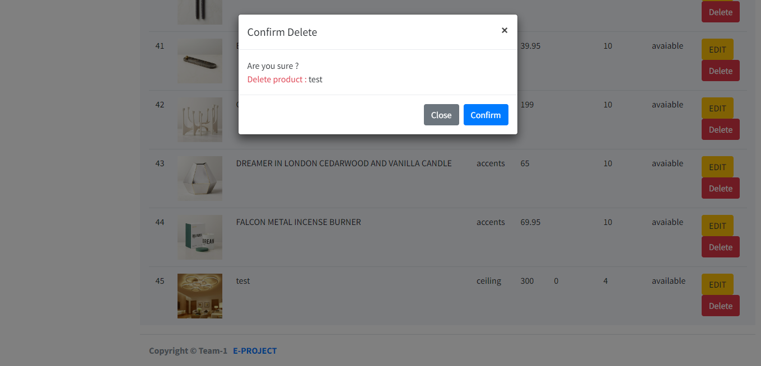

Add product

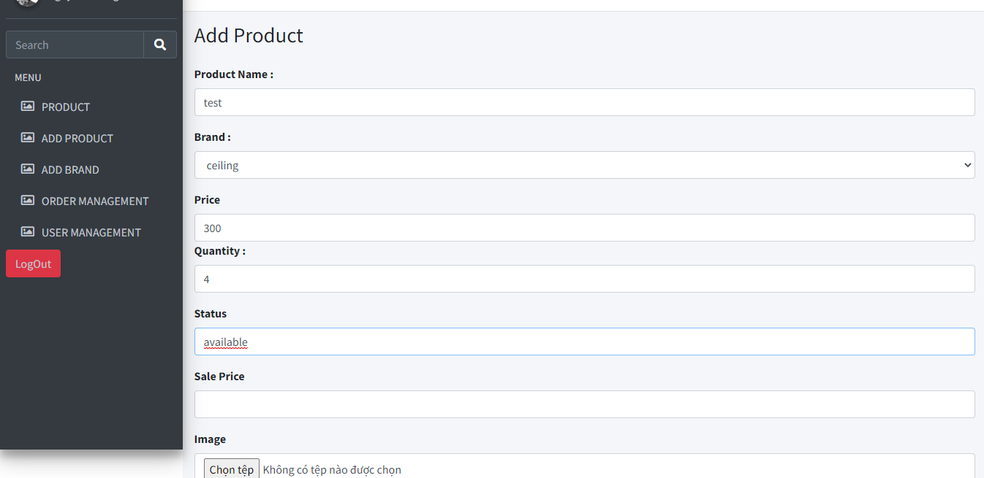

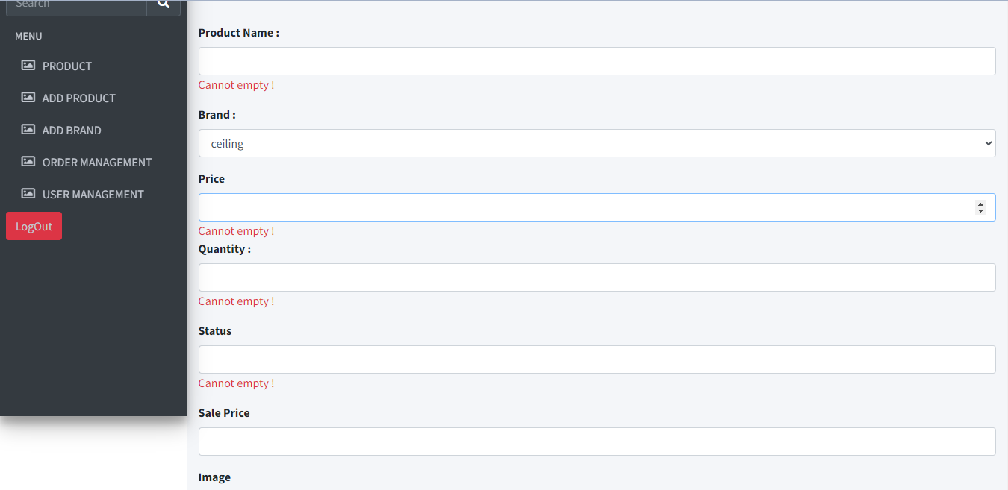



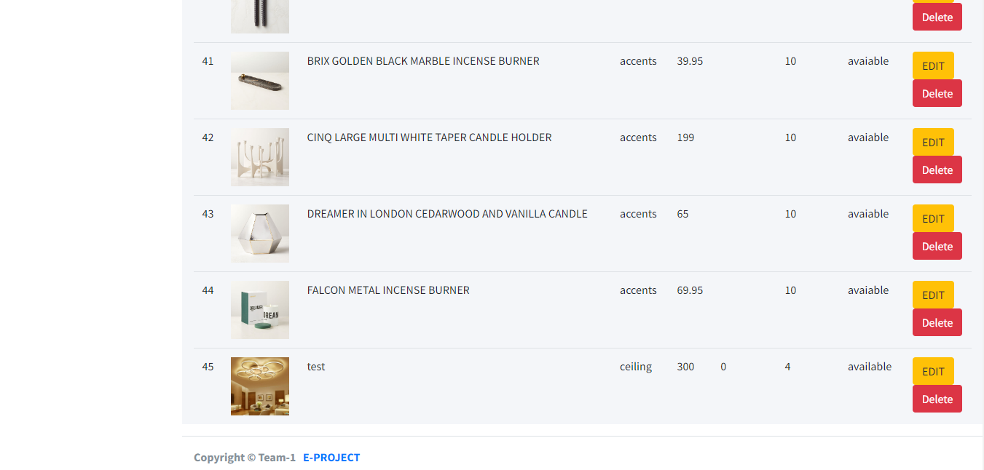

Add brand

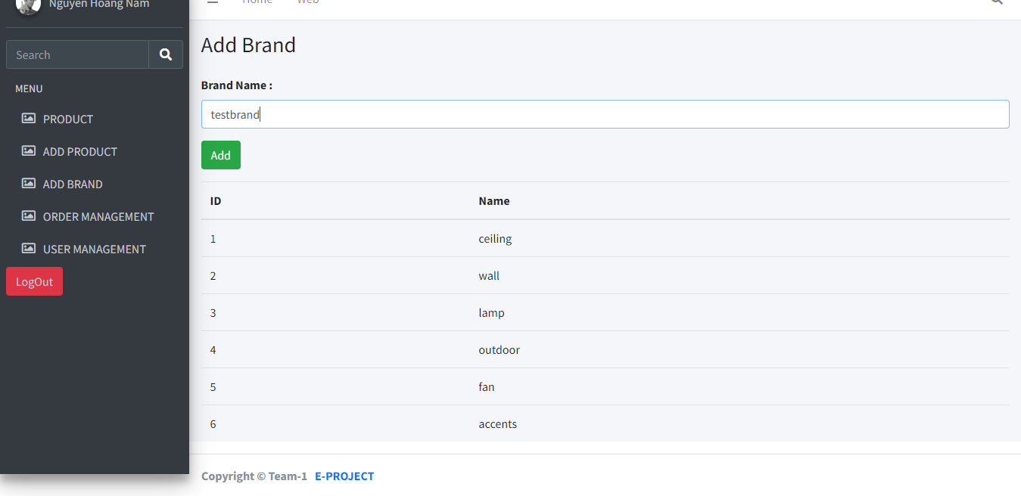

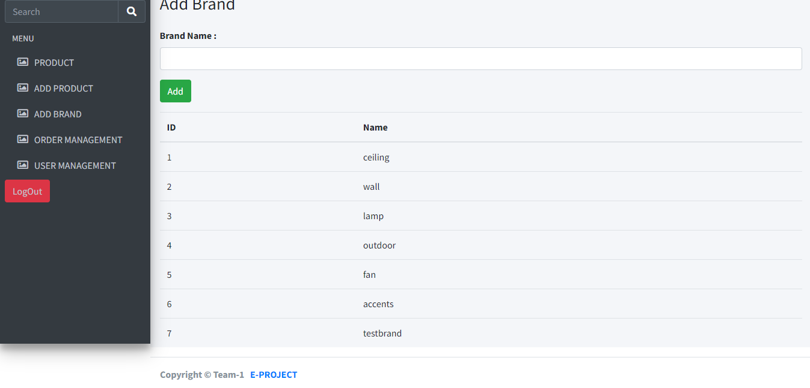

Order management

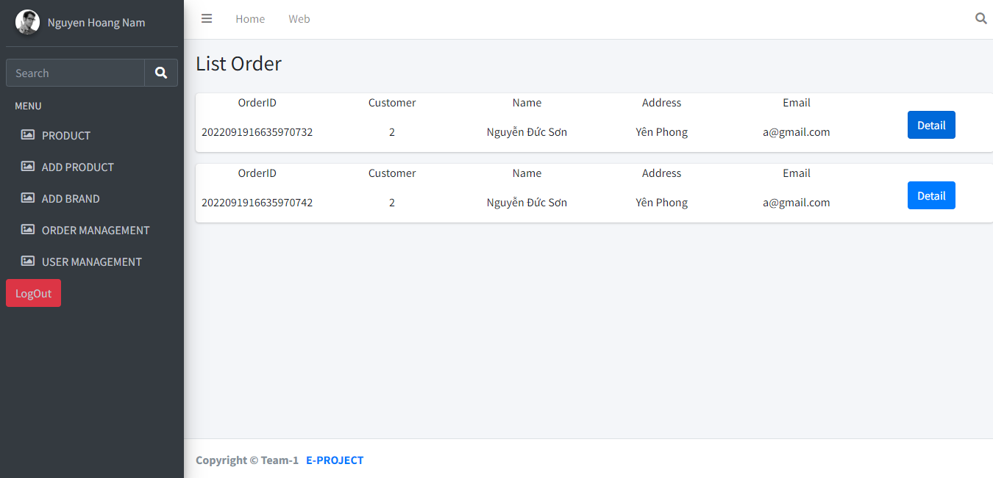

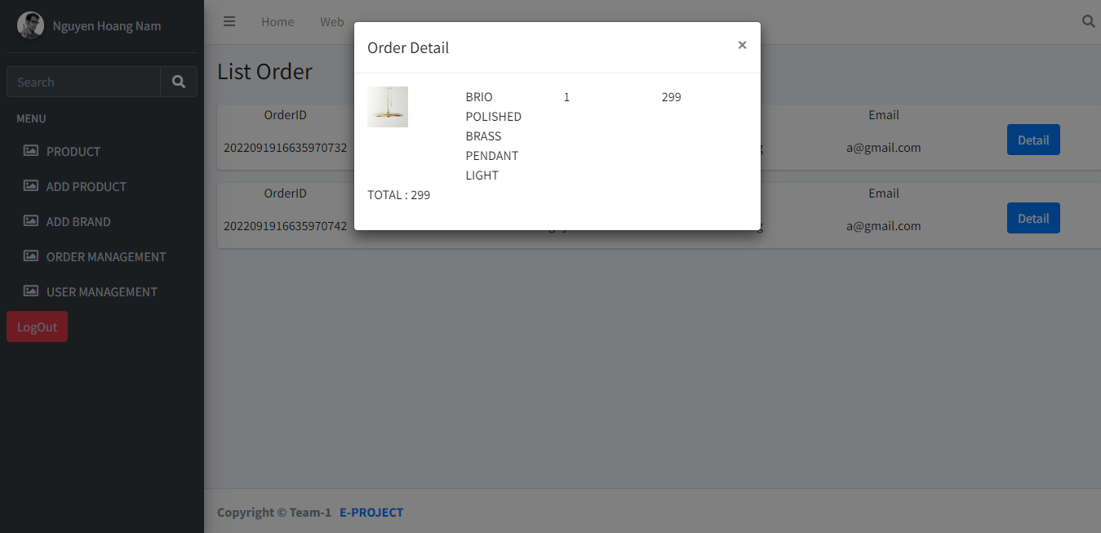

User management

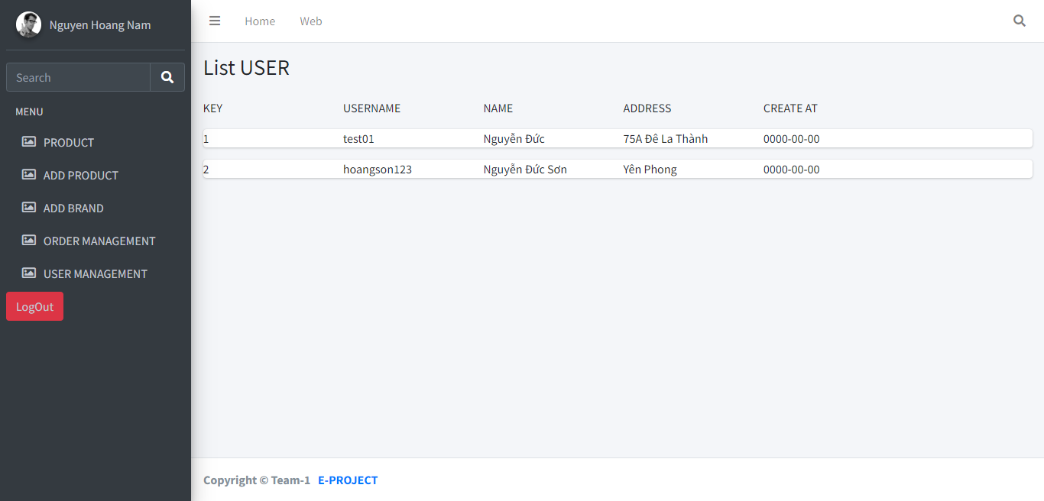

**4. Task sheet**

|  |  |  |  |
| --- | --- | --- | --- |
| Tasks | Nguyen Hoang Nam | Nguyen Duc Hoang Son | Nguyen Tai Thanh |
| Database Design | x |  | x |
| Front-End | | | |
| Index.html | x |  |  |
| Contact.html | x |  |  |
| About.html | x |  |  |
| Product.html |  | x |  |
| Login.html | x |  |  |
| Register.html | x |  |  |
| Product.html | x | x |  |
| Product-Detail.html |  |  |  |
| Cart.html | x |  |  |
| Template | x | x |  |
| Main.js | x |  |  |
| Vendor | x | x |  |
| Back-End | | | |
| Login.php | x | x |  |
| Config.php |  |  | x |
| Feedback.php |  |  | x |
| Product.php | x |  |  |
| Product-detail.php | x |  |  |
| Cart.php | x |  |  |
| Profile.php | x | x |  |
| History-order.php | x |  |  |
| Register.php | x | x |  |
| Admin-Side | x |  |  |
| Main.css | x | x |  |

**5. Validation Checklists**

- The cases in the form input have been checked.

- Enter the appropriate data.

- The data is related to each other according to the requirements.

- All pages are fine.

- All the links are working fine.

- Website is compatible with many different browsers.

- The functions are all working well.